**CODING ASSESSMENT (PYTHON)** Vinutha s

20/12/2023

1. Explain Python Module with examples

Modules are building blocks for organizing and reusing code in python.

They group related functions, classes and variables into a single file.

1. Import module in Python

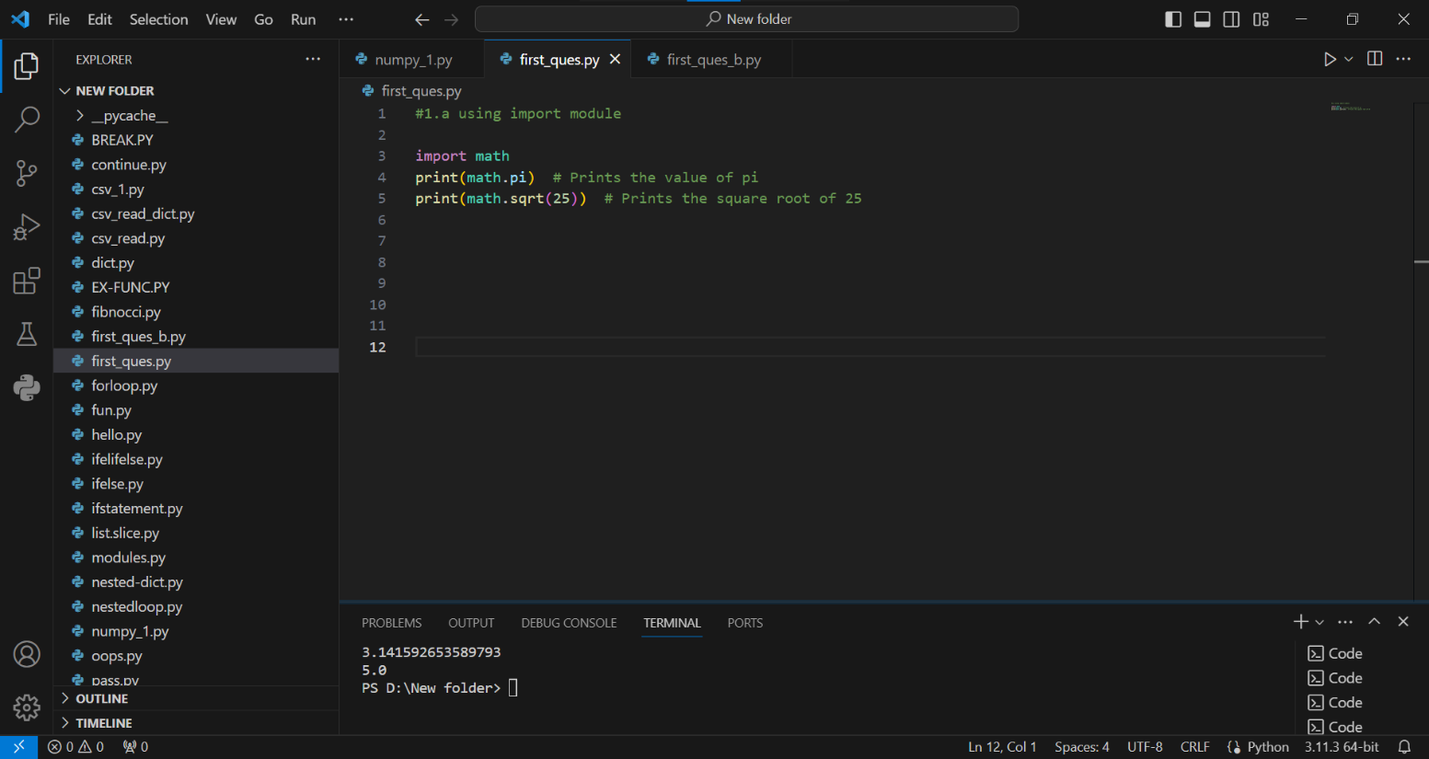Here I used a math inbuilt-module to make my calculations easier.

1. Renaming the Python module

We cannot rename a module after importing it. Instead, we can use an alias name as below.

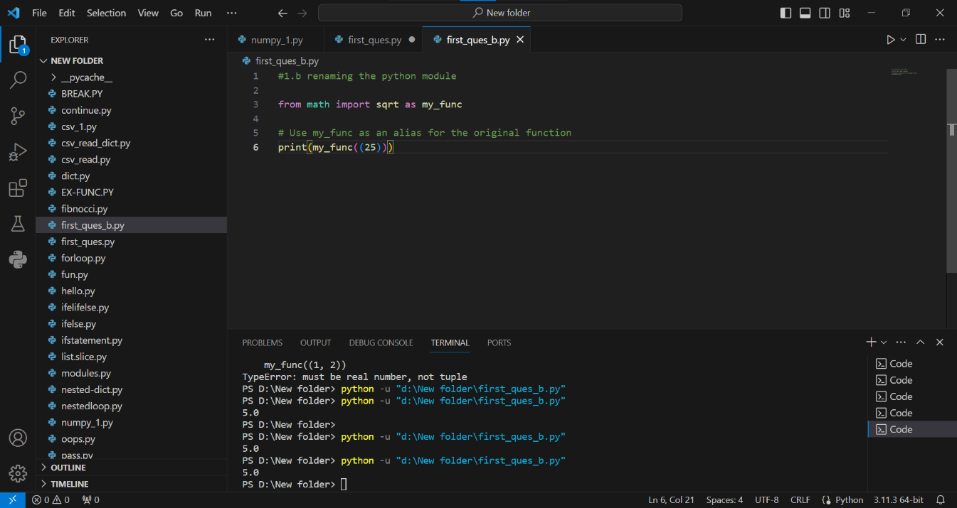

2. Explain Pandas and numpy using Examples in PYTHON

**Numpy: Both the pandas and Numpy are powerful libraries in python for data analysis.**

* **NumPy focuses on efficient numerical computation on large datasets.**
* **It provides multi-dimensional arrays called ndarrays for storing and manipulating numeric data.**
* 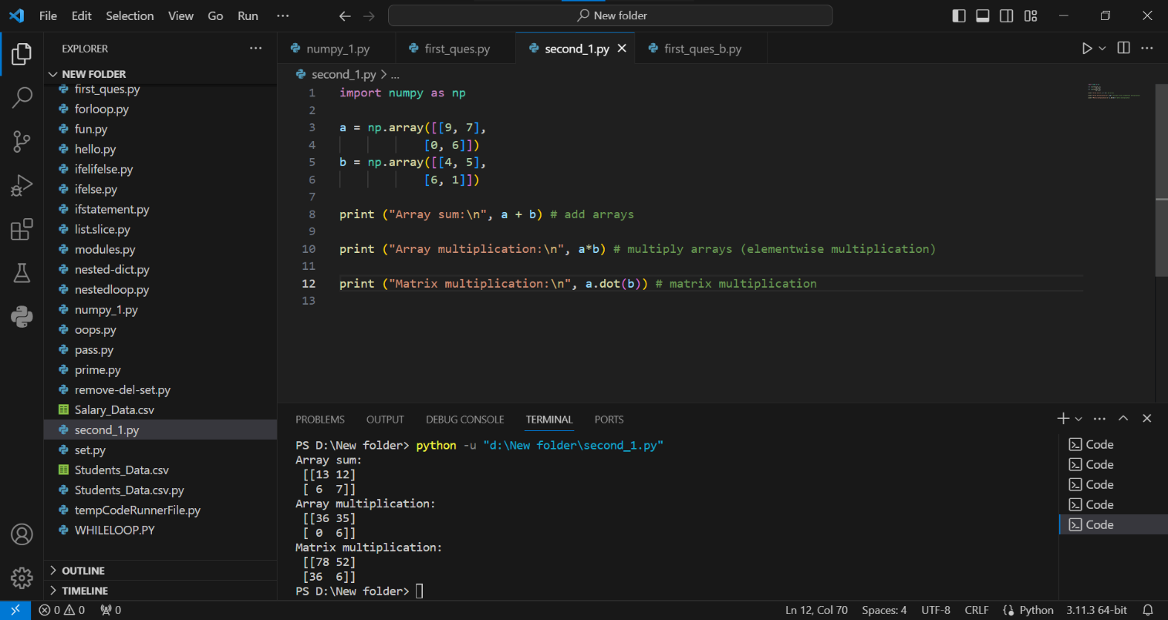**Here's an example of creating and using a NumPy array:**

**Pandas: Pandas builds upon NumPy and offers additional features for working with tabular data (data in rows and columns).**

**It provides data structures like Series (1D) and Data Frames (2D) with labelled axes and advanced indexing capabilities.**

